Lab Assistant Guide



Contents
WHA Specimen Labeling 5
Specimen Labeling Terminology 6
Blood 8
Blood Collection Terminology 8
In House Panel Tests 9
Blood Stability Guide (In-House Only) 10
Sodium Citrate Light Blue Top 13
Serum Red Top 13
SST Gold Top 14
Rapid Serum Tube 14
EDTA Lavender Top 15
EDTA Pink Top 15
Sodium Fluoride Gray Top 15
QuantiFERON TB Kit – Patient 17
QuantiFERON TB Kit – Employee 18
Urine 20
Urine Collection Terminology 20
Urine Stability Guide 21
24 Hour Urine 23
Sterile Urine Container 24
Sterile Urine Culture Tube 25
UA Tube 26
Swabs 27
Swab Collection Terminology 27
Swab Stability Guide 28
Aptima MTS Collection Tube 30
Culture Swab – Red Top 31
Fetal Fibronectin (FFN) 32
HSV Culture and COVID-19 Swab 33
Rapid Trich 34
E-Swab 35
Pathology 36
Pathology Collection Terminology 36
Pathology Stability Guide 36
Pap Smear Collection (With HPV testing) 37
Pap, HPV if ASCUS or No HPV Testing 38
Formalin Pathology Bottle 39
Orchard Workflows 40
Orchard Terminology 40
Orchard Sign In 41
Orchard Work Centers 42
Release Stored Orders 44
Find a Patient 46
Reference Labs 48
Order Choice Catalog 49
Processing OB Panels, Pap Smears, Urine and Biopsies 50
OB Panel 50
Urine 53
Pap Smear 55
Tissue Pathology 59
Draw Station Workflow 61
WildCard Workflow 64
Quest Test Menu 65
Quick Links 67
Helpful Hints 68
FAQ 69
Genetic Tests to Quest 71
Consent Forms - Genetic Pathology & Blood Collection 73
SST – Red/Yellow Top 75

WHA Specimen Labeling
All specimens must be labeled with an Orchard label (besides paps). Please refer to each individual example to see if an Epic label is required and label placement.
Each Epic label must be:
  - Initialed by the patient in the top right-hand corner of label.
  - Initialed by staff at the top right-hand corner of label. (If your current workflow includes your clinician initials, keep your process).
  - Source. The source of collection from any site other than arm/hand for blood draws must be written on the label.
  - Timed. Place the time of collection in the center on the right-hand side of the label.

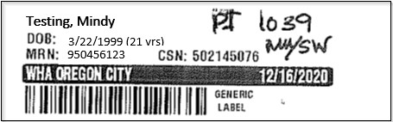

Any Orchard labels that can be initialed by the patient must be initialed on the right side of the label in a blank space away from the bar-coded area.
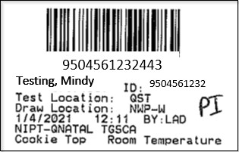
WHY? Any extra writing near the bar code on the label causes interference with testing at Central Lab.

Important Information:
- Epic labels have a bar code that is not necessary for lab/specimen processing, it can be covered with an Orchard label.
- Epic labels may be cut to fit specimen tubes. Make every effort to preserve the patient's name, date of birth (DOB), and medical record number (MRN).
- Always label specimens in tubes from left to right. Hold the capped end in your left hand and place the specimen on its side. Start the label at the left corner of the tube.
Goal: Have three patient identifiers that are available for cross check by Lab Assistants (name, DOB, MRN).

Specimen Labeling Terminology

The Orchard label has several points of information that will be useful to you while collecting and processing the sample.

Barcode: The barcode located on the Orchard label is important for the Central Lab because every sample is scanned in. The barcode is connected to the sample ID.
Sample ID: The sample ID is a unique number that is different for every patient and set of labs being run.
Patient information: Patient name, date of birth, and ID (MRN) are located on the Orchard label.
Test Location: Location where the sample will be run (CL, QST, LABCP).
Draw Location: Location where the sample was collected (TN, PKN, TA, etc.).
Collection Information: Collection date and time.
Phlebotomist: Name of person who collected the sample.
Test name: Name of the test being run. Can have multiple tests on one sample if they share the same collection requirements.
Specimen collection device: The collection device that needs to be used (SST, EDTA, APTIMA, etc.).
Transport Temperature: The temperature at which you send the sample with the courier (Room Temp or Refrigerated).

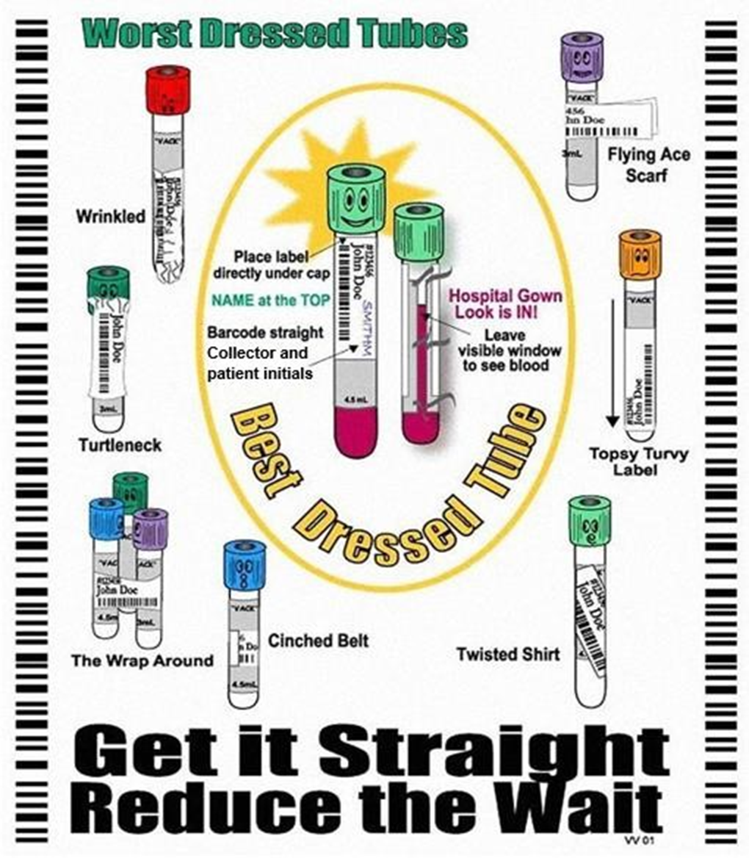

Blood
Some send-out blood tests have special handling and collection instructions that differ from the general process. Be sure to check the requisition and relevant clinical information that apply to each test. For any clarification, please contact the Central Lab.

Blood Collection Terminology

Serum: The liquid portion of blood after clotting and centrifuging has occurred.
Tubes Used:
- Gold top (SST - Serum Separator Tube)
  - It contains a clot activator and gel separator to help separate serum from cells after centrifugation.
- Red top (No Gel)
  - Contains no gel, only a clot activator or no additive at all.
  - Serum must be manually separated after centrifugation to avoid contamination from cells. This is done at Central Lab.
Common Uses: Chemistry and immunology.

Whole Blood/Plasma: Whole blood is blood that contains all its components—red cells, white cells, platelets, and plasma—without any separation. Plasma is the liquid portion of blood that remains after red and white blood cells and platelets are removed by centrifugation.
Tube Used:
- Purple top (EDTA, Whole Blood) – for hematology (e.g. CBC).
- Gray top (EDTA with fluoride, Plasma) – for glucose tests.
- Pink top (EDTA, Whole Blood/Plasma) – Similar to purple but used mainly for blood bank.
Common Uses: CBC, blood typing, and glucose measurements.

Hemolysis: The rupture of red blood cells, which can interfere with test results; often caused by rough handling or difficult draws.
Tube Inversion: Gently turning tubes end-over-end to mix blood with additives; required number of inversions depends on tube type.
TAT: Turnaround time. The time when the sample is received at the lab to when final results are available.
QNS: Quantity not sufficient. Not enough sample collected to run tests.
Fasting Specimen/Draw: Patient has not consumed anything except water for 8-12 hours.
Room Temperature/Ambient: 15°C to 25°C. Sample does not need to be refrigerated or frozen.
Refrigerated: 2°C to 8°C.
Frozen: ≤ –20°C.

In House Panel Tests

CBC: Complete Blood Count. Includes: WBC, RBC, Hemoglobin, Hematocrit, HCV, MCH, MCHC, RDW, Platelet, MPV, Neut %, Neut #, Lymph %, Lymph #, Mono %, Mono #, Eos %, Eos #, Baso %, Baso #.
ABC: Automated Blood Count. Includes: WBC, RBC, Hemoglobin, Hematocrit, MCV, MCH, MCHC, RDW, Platelet, MPV.
CMP: Comprehensive Metabolic Panel. Includes: Sodium Potassium, Calcium, Chloride, Carbon Dioxide, Anion Gap, Glucose, Urea Nitrogen, Creatinine, Alkaline Phosphatase, Alanine Amino Transferase (ALT), Aspartate Amino Transferase (AST), Bilirubin Total, Total Protein, Albumin, Globulin, A/G Ratio.
BMP: Basic Metabolic Panel. Includes: Sodium, Potassium, Calcium, Chloride, Carbon Dioxide, Anion Gap, Glucose, Urea Nitrogen, Creatinine.
LPR: Lipid Panel. Includes: Cholesterol, Triglyceride, HDL Direct, LDL Calculated, Cholesterol/HDL Ratio, Non-HDL Cholesterol.
PIHP: Pregnancy Induced Hypertension Panel. Includes: Aspartate Amino Transferase (AST), Urea Nitrogen, Creatinine, Uric Acid, CBC.
Thyroid Panel: Includes FT4 and TSH.

OB Panel (BLOOD): Includes ABO, Rh, Antibody Screen, CBC, Ferritin, Rubella, HCV, HbsAg, HIV, Syphilis.

Blood Stability Guide (In-House Only)
Central Lab only keeps in-house samples for seven days.

Test | Sample Required | Storage Requirement | Stability
CBC w/ auto diff, ABC, H&H | 1 Lavender EDTA  Whole Blood | Refrigerate | 48 hours Refrigerated
OB Panel w/HIV | 1 Gold SST, 2 Lavender EDTA, 1 Pink EDTA | Refrigerate | EDTA Lav 48 hours Refrigerated  Serum -≤48 hours Refrigerated  EDTA Pink- 3 days Refrigerated
BMP  Basic Metabolic Panel | 1 Gold SST  Serum | Refrigerate  Spin within 2 hrs. post draw | 3 days Refrigerated
CMP  Comprehensive Metabolic Panel | 1 Gold SST  Serum | Refrigerate  Spin within 2 hrs. post draw | 3 days Refrigerated
Lipid Panel  (fasting- 12HR) | 1 Gold SST  Serum | Refrigerate | 3 days Refrigerated
PIH Panel  (ABC, Creatinine, BUN, AST, Uric) | 1 Lavender EDTA  Whole Blood  1 Gold SST  Serum | Refrigerate | EDTA Lav 48 hours Refrigerated  Serum 5 days Refrigerated
ABO/Rh | 1 Pink EDTA  Whole Blood | Refrigerate | 3 days Refrigerated
Antibody Screen | 1 Pink EDTA  Whole Blood | Refrigerate | 3 days Refrigerated
Β-HCG | 1 Gold SST  Serum | Refrigerate | 5 days Refrigerated
Estradiol | 1 Gold SST  Serum | Refrigerate | 48 hours Refrigerated
Free T4 | 1 Gold SST  Serum | Refrigerate | ≤7 days Refrigerated
FSH | 1 Gold SST  Serum | Refrigerate | 6 days Refrigerated
HBsAg | 1 Gold SST  Serum | Refrigerate | ≤48 hours Refrigerated
HCV | 1 Gold SST  Serum | Refrigerate | ≤48 hours Refrigerated
Progesterone | 1 Gold SST  Serum | Refrigerate | ≤7 days Refrigerated
Prolactin | 1 Gold SST  Serum | Refrigerate | 5 days Refrigerated
Rubella IgG | 1 Gold SST  Serum | Refrigerate | ≤7 days Refrigerated
TSH | 1 Gold SST  Serum | Refrigerate | ≤7 days Refrigerated
HIV | 1 Gold SST  Serum | Refrigerate | ≤7 days Refrigerated
Syphilis-Treponema | 1 Gold SST  Serum | Refrigerate | ≤ 7 days Refrigerated
Ferritin | 1 Gold SST  Serum/Plasma | Refrigerate | 5 days Refrigerated

Albumin | 1 Gold SST  Serum | Refrigerate | ≤7 days Refrigerated
Alk Phos  (Alkaline Phosphatase) | 1 Gold SST  Serum | Refrigerate | 4 days Refrigerated
ALT  (SGPT) | 1 Gold SST  Serum | Refrigerate | ≤7 days Refrigerated
AST  (SGOT) | 1 Gold SST  Serum | Refrigerate | ≤7 days Refrigerated
Bilirubin, Total | 1 Gold SST  Serum | Refrigerate | ≤7 days Refrigerated
BUN  (Blood Urea Nitrogen) | 1 Gold SST  Serum | Refrigerate | 5 days Refrigerated
Calcium | 1 Gold SST  Serum | Refrigerate | ≤7 days Refrigerated
Carbon Dioxide | 1 Gold SST  Serum | Refrigerate | 3 days Refrigerated
Chloride | 1 Gold SST  Serum | Refrigerate | ≤7 days Refrigerated
Cholesterol | 1 Gold SST  Serum | Refrigerate | ≤7 days Refrigerated
Creatinine | 1 Gold SST  Serum | Refrigerate | 30 days Refrigerated
Glucose | 1 Gold SST  Serum | Spin within 2 hrs. post draw  Refrigerate | ≤7 days Refrigerated
Glucose 3HR GTT | 4 Sodium Fluoride Gray (F, 1hr, 2hr, 3hr) | Room Temp or Refrigerated | 24 hours Room Temp  ≤7 days Refrigerated
HDL | 1 Gold SST  Serum | Refrigerate | 3 days Refrigerated
Hemoglobin A1C | 1 Lavender EDTA | Refrigerate | ≤3 days Refrigerated
Potassium | 1 Gold SST  Serum | Refrigerate | ≤7 days Refrigerated
Protein, Total | 1 Gold SST  Serum | Refrigerate | 3 days Refrigerated
Sodium | 1 Gold SST  Serum | Refrigerate | ≤7 days Refrigerated
Triglycerides | 1 Gold SST  Serum | Refrigerate | ≤7 days Refrigerated
Uric Acid | 1 Gold SST  Serum | Refrigerate | 5 days Refrigerated

Please refer to the Quest Draw Station Order Choices for tests that cannot be drawn at WHA. If you have any questions, please contact the Central Lab.

Sodium Citrate Light Blue Top

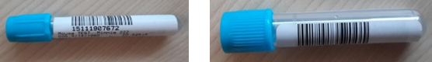

Required Label: Orchard.
Labeling Instructions: Print label from Orchard, have patient initial in blank space after verifying identity, place on tube while leaving open space to see blood level in tube.
Packaging Instructions: Place in specimen bag, keep at room temperature, and must be tested within 1-4 hours.
Common Errors: Sodium citrate not being used in addition to an EDTA when a patient is a clumper.
Only use this if the patient is a known platelet clumper. There will be an Orchard notification if you need to draw a sodium citrate tube.

Serum Red Top

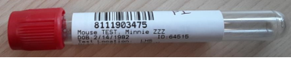

Required Label: Orchard.
Labeling Instructions: Print label from Orchard, have patient initial in blank space after verifying identity, place on tube while leaving open space to see blood level in tube.
Packaging Instructions: Draw and send room temperature to Central Lab (CL spins and pours off serum).
Common Errors: Spun in clinic (no separator in tube, reconstitutes back together unless serum is poured off immediately after spinning while at CL).
Common Tests: 17- Hydroxyprogesterone.

SST Gold Top

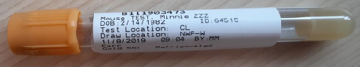

Required Label: Orchard.
Labeling Instructions: Print label from Orchard, have patient initial in blank space after verifying identity, place on tube while leaving open space to see blood level in tube.
Packaging Instructions: Allow to clot for 30 minutes, spin in centrifuge within 2 hours of drawing, place in specimen bag, and place in fridge for courier pickup. Some tests have more rigorous requirements or specific patient preparation. Be sure to follow the instructions for the specific test you’re drawing from either the Quest test menu or contact CL.
Common Errors: Not spun within two hours of draw, spinning too early (before the sample has clotted/30 minutes).
Common Tests: All in-house chemistry and immunology testing, testosterone, AMH, iron deficiency panel, vitamin d.

Rapid Serum Tube
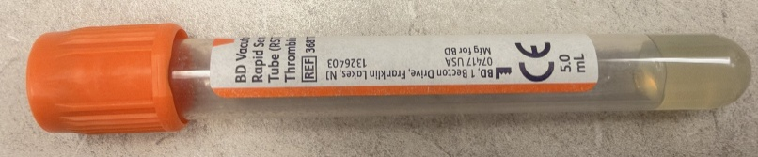
Required Label: Orchard.
Labeling Instructions: Print label from Orchard, have patient initial in blank space after verifying identity, place on tube while leaving open space to see blood level in tube.
Packaging Instructions: Place in specimen bag, refrigerate.
Common Tests: BMP, CMP, 1HR and fasting glucose ONLY.
Let sample clot for 5 minutes and then centrifuge as normal.
These tubes are for end of day draws that contain glucose. Unspun, glucose stability in an SST is only two hours. To prevent rejection due to stability, use RCTs for late day draws where CMP, BMP or Glucose is ordered. This way, the tubes can be spun before transport, and glucose stability won’t be compromised. Please note- Use SSTs for all other late day draws. RCTs are intended for glucose related orders only where sending an unspun SST will exceed the 2-hour stability limit

EDTA Lavender Top

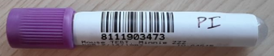

Required Label: Orchard.
Labeling Instructions: Print label from Orchard, have patient initial in blank space after verifying identity, place on tube while leaving open space to see blood level in tube.
Packaging Instructions: Place in specimen bag, refrigerate.
Common Tests: Blood counts (ABC, CBC, Hematocrit, and Hemoglobin), A1C.

EDTA Pink Top

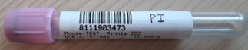

Required Label: Orchard.
Labeling Instructions: Print label from Orchard, have patient initial in blank space after verifying identity, place on tube while leaving open space to see blood level in tube.
Packaging Instructions: Place in specimen bag, refrigerate.
Common Tests: Blood typing/blood bank (ABO/RH, Antibody screening).

Sodium Fluoride Gray Top

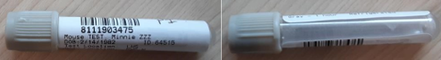
Please review this guide for more information: Glucose Tolerance Test Guide

1-hour GTT is a screening test. Best Practice is to draw the patient ON TIME. You have up to a 10 min window after draw time
3-hour GTT is a diagnostic test. Best Practice is to draw the patient ON TIME. You have up to a 5 min window after draw time

Required Label: Orchard.
Labeling Instructions: Print label from Orchard, have patient initial in blank space after verifying identity, place on tube while leaving open space to see blood level in tube.
Packaging Instructions: Place in specimen bag, send room temperature.
Common Tests: 3-hour GTT, 2-hour GTT.

QuantiFERON TB Kit – Patient

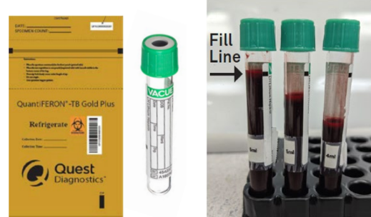

Required Label: Orchard.
Labeling Instructions: Print label from Orchard, have patient initial in blank space after verifying identity, place on tube while leaving open space to see blood level in tube.
Specimen Handling: Invert the tube 8-10 times (do not shake), fill out information on outside of specimen bag, place in gold QuantiFERON bag, and keep in the fridge for courier pickup.
Common Errors: Keeping the specimen at room temperature, not labeling with required information (ex: patient name, date of birth, test name, time of draw, date of draw, phlebotomist initials).
Quest MUST receive the sample within 48 hours of collection.
If you are drawing a TB on a patient, it must be ordered in Epic/Orchard. If you are drawing a TB on an employee, please refer to the workflow below.

QuantiFERON TB Kit – Employee

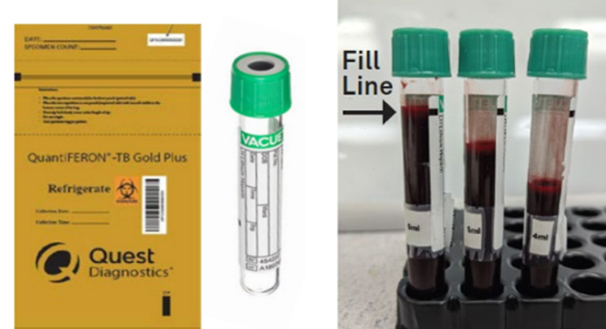

Please refer to the complete employee health collection workflow here: New Hire Lab Draw Workflow. This link includes the necessary paperwork to fill out when completing an employee draw.
This workflow is for WHA employees only.
Required Label: Blank Orchard label/deadstock label.
Labeling Instructions: Fill out label including patient name, date of birth, date and time of draw, phlebotomists’ initials. Label the outside of the gold bag with collection date and time.
Specimen Handling: Invert the tube 8-10 times (do not shake), fill out information on outside of specimen bag, place in gold QuantiFERON bag, and keep in the fridge for courier pickup.
Common Errors: Keeping the specimen at room temperature, not labeling with required information (ex: patient name, date of birth, test name, time of draw, date of draw, phlebotomist initials).
Quest MUST receive the sample within 48 hours of collection.
Additional Employee Heath Labs (if applicable)

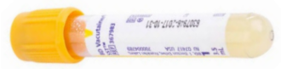

Please refer to the complete employee health collection workflow here: New Hire Lab Draw Workflow
This link includes how to fill out the necessary paperwork when completing an employee draw.
This workflow is for WHA employees only.
Required Label: Blank Orchard label.
Common tests: MMR, Varicella, Hepatitis B Titer. Rubella is run in house and requires an additional gold SST to be drawn.
Labeling Instructions: Fill out label including patient name, date of birth, date and time of draw, phlebotomists’ initials.
Specimen Handling: Same as regular SST. Please refer to instructions above.

Urine

Urine Collection Terminology

CATH: Sample collected from a catheter.

Clean Catch (midstream): Clean catch mid-stream patient uses two towelettes to clean. Void the first portion of urine into toilet, catch middle portion into container, and void last portion into toilet
Random Urine: A sample collected at any time of day without specific preparation.
First Morning Urine: First urine of the day.
24-Hour Urine: Urine collected over a period of 24 hours. Please refer to the 24-Hour Urine section for more information.

Urine Stability Guide

Urine tests are not limited to what is on the stability guide. Please refer to the Order Choice Catalog or Central Lab for other tests.

Test | Sample Required | Storage Requirements | Stability | Performing Lab
24 Hour Protein | 24-hour Urine  Random/24 Hour Urine | Refrigerated | 5 days Refrigerated  - Patient needs to bring back sample ASAP after collection | Quest
Creatinine Clearance | 24-hour Urine  SST  Random/24 Hour Urine | Refrigerated | 7 days Refrigerated  - Patient needs to bring back sample ASAP after collection | Quest
Urine Drug Screen | Unpreserved Urine  Random | Refrigerated | 7 days Refrigerated | Quest
Protein/Creatinine Ratio | Unpreserved Urine  Random | Refrigerated | 5 days Refrigerated | Quest
Culture Urine  Culture Urine Special  Culture Urine Prenatal w/GBS Susceptibilities | Preserved urine in gray top  Clean Catch/CATH | Room Temp | Preserved:  48-hour Room Temp  Unpreserved:  24 hours Refrigerated | Quest
Urinalysis Micro | Preserved urine in a red/yellow top  Clean Catch/CATH | Room Temp | Preserved:  72 hours Room Temp  Unpreserved:  24 hours Refrigerated | Quest
Urine HCG | Unpreserved Urine  First Morning Urine | Test immediately | Test immediately | In Clinic
Urinalysis Dip | Unpreserved Urine  Clean Catch/CATH | Test immediately | Test immediately | In Clinic

24 Hour Urine
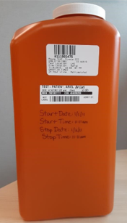

Please review and use the following 24 Hour Urine collection guide: 24 Hour Urine Collection Patient Instructions
Required Label(s): Epic and Orchard.
Labeling Instructions: Place an Epic label on the jug PRIOR to collection and Orchard label when the jug is returned.
WHY? The jug MUST be labeled prior to collection to ensure that the sample being returned is for the correct patient; this is also best practice. The sample must be kept in the fridge during the full collection period to maintain sample stability and follow test guidelines. If a patient does not collect for the full collection period, the sample can still be processed but the result will need to be interpreted with caution.
Specimen handling: Ensure lid is closed, refrigerate during whole collection period, put jug in large zip lock bag, put the requisition in a green specimen bag and put that into the large bag with the jug.
Common Errors: Not labeling jug until AFTER collection, sample was not kept in the fridge for the entire collection process, patient not collecting for the full 24 hours. Please be sure to read all the required clinical information questions in Orchard. They can differ between tests.
Common Tests: Urine Protein Timed and Creatinine Clearance.

Sterile Urine Container
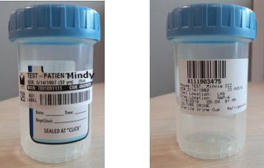

Please refer to the Quest urine guide for more information: Quest Urine Collection Containers and Orders

Required Label(s): Epic and Orchard.
Labeling Instructions: Place both Epic and Orchard label on specimen container.
Packaging Instructions: Ensure lid is closed until the click is heard, place in specimen bag and refrigerate within 2 hours of collection.
Common Errors: Not closed to click, no label attached.
Common Tests: Urine Drug Screen, Urine Mycoplasma/Ureaplasma, and Urine Protein/Creatinine Ratio.

Sterile Urine Culture Tube

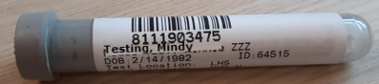

Please refer to the Quest urine guide for more information: Quest Urine Collection Containers and Orders & Transferring Urine Preservative Tubes for Transport

Required Label: Orchard.
Labeling Instructions: Place Orchard label over existing blank label on tube. Leave a window open to see quantity of the sample.
Packaging Instructions: Follow the provided Quest urine collection guidelines to see how to properly transfer urine into the sterile urine culture tube.
Common Errors: Not placing label on tube.
Common Tests: USED ONLY FOR URINE CULTURES (Culture Urine, Culture Urine Special, Culture Urine Prenatal w/GBS Susceptibilities).
Routine Culture vs Special vs Prenatal

Culture Urine: This is our normal urine culture order choice. Quest may result large bacterial colony findings, normal urogenital flora, and GBS without susceptibilities. If susceptibility is an option, there is typically a three-day window to add those on.

Culture Urine Special: This is for samples that are from a catheter. This special order choice tells the Quest lab to report any bacterial colony count. If the source is CATH the system will automatically switch the order from the routine Culture Urine to Urine, Culture, Special. This does not require any additional information, process like normal.
Culture Urine Prenatal w/GBS Susceptibilities: This order is only for pregnant patients. If GBS is found, Quest will automatically do susceptibilities. This order choice is part of the OB Panel and/or can be ordered on its own.

UA Tube

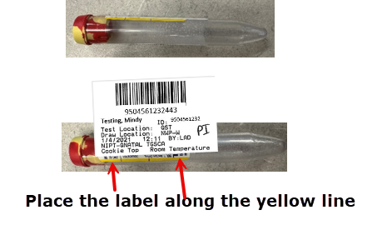

Please refer to the Quest urine guide for more information: Quest Urine Collection Containers and Orders & Transferring Urine Preservative Tubes for Transport
Required Label: Orchard.
Labeling Instructions: Place Orchard label over existing blank label on tube along the yellow line. Leave a window open to see quantity of the sample.
Packaging Instructions: Follow the provided Quest urine collection guidelines to see how to properly transfer urine into the sterile urine culture tube.
Common Errors: Not placing label on tube.
Common Tests: USED ONLY FOR UA DIP AND MICROSCOPIC.

Swabs

Please refer to the Swabs and Orders tip sheet for all updated collection and test information: Swabs and Orders Tip Sheet

Swab Collection Terminology

Self-collect: Patient collected sample under clinical guidance (only available for select tests).
Clinician/Provider collect: Swab that was collected by a provider. This can also be an MA/nurse that has been trained on the specific collection protocol and is working under the patient’s provider.
Under clinical supervision: Swab must be collected either by a provider/clinician or by the patient under the provider supervision in a clinical setting.
Source: Location where the swab was used (skin, vaginal, oral, anal, etc).
Vaginitis Panel: CV/TV, Trichomonas Vaginalis, Candida Glabrata, Candida Group, Bacterial Vaginosis.

Swab Stability Guide
Please review the Culture Tests resource: WHA Culture Tests.

Swab tests are not limited to what is on the stability guide. Please refer to the Order Choice Catalog or Central Lab for other tests.

Central Lab only keeps in-house samples for seven days.

Test | Sample Required | Storage Requirement | Stability | Preforming Lab
Vaginitis Panel | Aptima | Room Temperature | 30 days Room Temperature | CL/Quest
CT/GC | Aptima | Room Temperature | 30 days Room Temperature | CL/Quest
Ureaplasma/Mycoplasma | Aptima | Room Temperature | 14 days Room Temperature | Quest
GBS | Culture Swab | Room Temperature | 24-hours Room Temperature  4 days Refrigerated | CL
Genital Culture | Culture Swab | Room Temperature | 48-hours Room Temperature | Quest
Yeast/Fungus Culture | Culture Swab | Room Temperature | 72 hours Room Temperature | Quest
Fetal Fibronectin | FFN Swab | Refrigerated | 8-hours Room Temperature  72 hours Refrigerated | Quest/  LabCorp
HSV PCR | VTM | Refrigerated | 48-hours Room Temperature  7 days Refrigerated | Quest
Trichomonas | Rayon Tipped Swab | Room Temperature | 24-hours Room Temperature  36 hours Refrigerated | CL
Aerobic Anaerobic Culture | E-Swab | Room Temperature | 48-hour Room Temperature | Quest

Aptima MTS Collection Tube

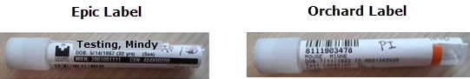

Required Label(s): Epic and Orchard.

Epic: Print, cut label to fit tube length, and place label on container, not covering patient name, DOB or MRN on Orchard label.

Orchard: Patient initials, time, staff initials, and specimen source.

Place the Orchard label below the MRN as shown below. Trim off the right side of Epic label to fit container. Ensure the swab inside is the correct swab (pink handled swab)

Packaging Instructions: Keep at room temperature for courier pickup.

- Vaginitis panel– One tube only
- Chlamydia and Gonorrhoeae Amplification (CT/GC)- One tube only
- Collecting Vaginitis panel & GC/CT (vaginal collection) – One tube only, shared
- Collecting Ureaplasma/Mycoplasma (vaginal collection) – One tube only
- Collecting Ureaplasma/Mycoplasma and Vaginitis Panel/ GC/CT (vaginal collection) – two separate swabs and tubes must be used, one for the Ureaplasma/Mycoplasma and one for the Vaginitis Panel with or without GC/CT.

If a provider is collecting a CT/GC from two different sources (oral/vaginal/rectal), use two separate swabs and clearly label the sources on the tubes.

Vaginal source for CT/GC and Vaginitis Panel can be self-collected in clinic.
Oral and rectal sources for CT/GC and Vaginitis Panel need to be collected by the provider.
Ureaplasma/Mycoplasma needs to be collected by the provider.

Common Errors: No label on specimen, no source written on label, punctured foil top, no liquid inside of tube, a tube with two or zero swabs.

WHY? These are all causes for rejection. If the foil top has been punctured, there is a chance the sample has been contaminated. If there is no liquid inside the tube, there will be nothing for the analyzer to test. A tube with two or zero swabs does not meet the testing requirements, one collection swab needs to be present.

Culture Swab – Red Top

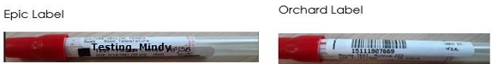

Required Label(s): Epic and Orchard.

Epic: Print, cut label to fit tube length, and place label on container, not covering patient name, DOB or MRN on Orchard label.

Orchard: Patient initials, time, staff initials, and specimen source.

This culture tube is thin. Place the Epic label close to the red cap and then place the Orchard label so that the patient’s name, DOB and MRN can be seen. If the patient has a long name, some information will be lost, however, DOB and MRN will be visible for cross check for processing. Do not put Orchard label in the tube indentation.

Packaging Instructions: Place in specimen bag, room temperature.
Common Errors: Incorrect labeling, no swab inside of tube, not placing swab into tube immediately.
Common Tests: GBS, Genital Culture, Yeast/Fungus culture, MRSA.
For GBS, if the patient is allergic to penicillin the system will automatically switch the order to Culture, Strep Group B. You do not need to change anything in Epic or Orchard, just process like normal.
GBS can be self-collected in clinics, patients cannot take a culture swab home. All other cultures need to be clinician collect.

Fetal Fibronectin (FFN)

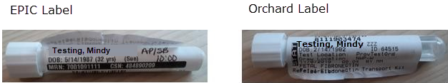

Required Label(s): Epic and Orchard Labels.
Epic: Print, cut label to fit tube length, and place label on container, not covering patient name, DOB or MRN on Orchard label.

Orchard: Patient initials, time, staff initials, and specimen source.

Packaging Instructions: Place in specimen bag, refrigerate.
Common Errors: No time or patient initials on label, no swab in tube.
This test is typically ordered STAT. If it is not, double check with the provider. If it is STAT call 1-866-697-8378 to schedule a STAT Quest pickup from the clinic. *Call Central Lab once courier is called so they can release the order in Orchard. *
If not ordered STAT, process sample like usual.

Clinician collect only
- If you are located at NB, please refer to your PCS for FFN workflow.

HSV Culture and COVID-19 Swab

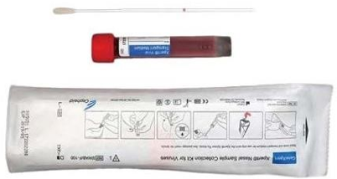

Required Label(s): Epic and Orchard.
Epic: Print, cut label to fit tube length, and place label on container, not covering patient name, DOB or MRN on Orchard label.

Orchard: Patient initials, time, staff initials, and specimen source.

Packaging Instructions: Place in specimen bag, refrigerate within 30 minutes of collection, send to CL on ice.
Common Errors: Incorrect labeling, no swab inside of tube, not placing swab into tube immediately, leaving at room temperature.
Common Tests: HSV and Covid-19.
HSV clinician collect only.
Covid-19 self-collect.
You may see different colors for this swab (green, red, blue).
For WHA purposes, VTM (viral transport media) and UTM (universal transport media) mean the same thing. You may see those used interchangeably.

Rapid Trich

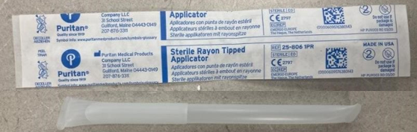

Required Label(s): Epic and Orchard.
Epic: Print, cut label to fit tube length, and place label on container, not covering patient name, DOB or MRN on Orchard label.

Orchard: Patient initials, time, staff initials, and specimen source.

Packaging Instructions: Place in specimen bag, refrigerate.
Common Errors: Incorrect labeling, no swab inside of tube.
Rapid Trich testing should be a clinician supervised collection. This means that the swab must be collected either by a provider/clinician or by the patient under the provider supervision in a clinical setting.

E-Swab

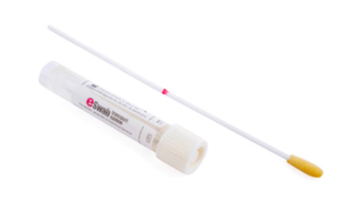

Required Label(s): Epic and Orchard.
Epic: Print, cut label to fit tube length, and place label on container, not covering patient name, DOB or MRN on Orchard label.

Orchard: Patient initials, time, staff initials, and specimen source.

Packaging Instructions: Place in specimen bag, room temperature.
Common Errors: Incorrect labeling, no swab inside of tube.
Common Tests: Aerobic Anaerobic Culture.
Clinician collect only.
- For breast milk cultures collect sample in sterile urine container, then immediately after collection soak up the milk using an E-Swab.

Pathology

Pathology Collection Terminology

EMB: Endometrial biopsy.
EMC: Endometrial curetting.
ECB: Endocervical biopsy.
ECC: Endocervical curetting.
CP: Cervical Polyp.
Bx: Biopsy.
1 o’clock-12 o’clock: Indicated locations for tissue collection

Pathology Stability Guide

Central Lab only keeps in-house samples for seven days.

Test | Sample Required | Storage Requirement | Stability | Preforming Lab
Pap Smear (Pap with HPV, ASCUS, No HPV) | Thin Prep | Room Temp | 30 Days Room Temp | HPV- CL  Pap Smear- Quest
Tissue Pathology | Formalin Container | Room Temp | 30 Days Room Temp | Quest
HPV Only | Thin Prep | Room Temp | 30 Days Room Temp | CL

Pap Smear Collection (With HPV testing)

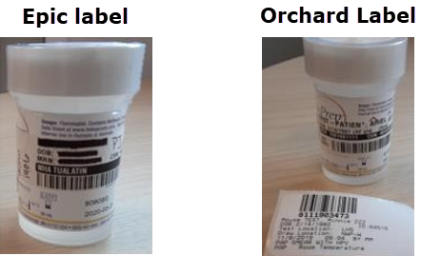
Required Label(s): Epic and Orchard.
Epic: Epic label w/patient initials, time, staff initials
Orchard: Print and place label in specimen bag with pap.
Labeling Instructions: Place Epic sticker on the specimen container. Do not place low on the container, keep above the rainbow line on the bottom of the container. Place the Orchard label in the bag with the specimen. Do not place the Orchard label on container, the Central Lab will complete the labeling process.
WHY? The analyzer cannot perform test if label is on incorrectly. To ensure the HPV is performed correctly, Central Lab will label.
Packaging Instructions: Ensure lid is on correctly and tight, place in specimen bag, room temperature.
Common Errors: No patient initials, time, staff initials on Epic label, lid not tightened all the way.
Common Tests: Pap Smear with HPV.

If you are processing an HPV ONLY sample, there will not be an Orchard label that prints out. The sample will only have the Epic label. Process the order in Orchard normally, place in specimen bag with note that says “HPV ONLY”.

Pap, HPV if ASCUS or No HPV Testing

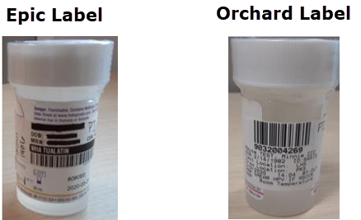

Required Label(s): Epic and Orchard.
Epic: Epic label w/patient initials, time, staff initials
Orchard: place on specimen container
Labeling Instructions: Place Epic and Orchard labels as below, small overlap is okay. No pertinent information is compromised. Do not place labels below the rainbow line at the bottom of the container. The Orchard label can be placed on this pap because CL will not be running the HPV in house.
WHY? Since there is no HPV being performed, the label does not need to be in a specific place.
Packaging Instructions: Ensure lid is on correctly and tight, place in specimen bag, room temperature.
Common Errors: No patient initials, time, staff initials on Epic label, lid did not tighten all the way.
Common Tests: Pap Smear HPV if ASCUS, no HPV.

Formalin Pathology Bottle
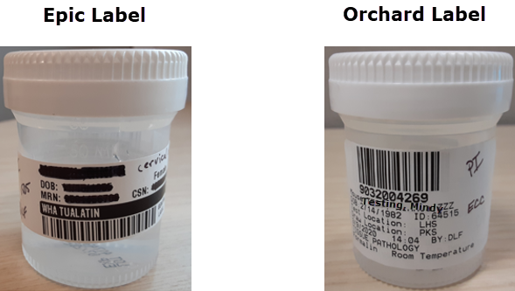

Regular Size (60 mL), Medium Size (40 mL), Small Size (15 mL)
Only one order placed per patient regardless of the sample quantity.
Required Label(s): Epic and Orchard.
Labeling Instructions:
Epic: Epic label w/patient initials, time, staff initials, source
Orchard: Print and place label on container, not covering patient name, DOB or MRN, write source and number on label corresponding with number in Epic/Orchard.
If you have more than one specimen, please enter the additional sources to the clinical information section.
WHY? To ensure that we provide all the necessary information for the pathologists, every sample container must be labeled with the specimen source. This source must match exactly what is on the requisition. If there is a discrepancy between the requestion and the sample, it will be sent back to the clinic to be corrected.
Packaging Instructions: Ensure lid is on correctly and tightly to avoid leaking of formalin, place in bag, room temperature. If there is significate leakage the sample will be sent back to the clinic for correction.
Common Errors: Specimen source not on label, lid not fully closed, source on container does not match what is on the requisition, two orders put in for one patient.
Common Tests: CCS and non-CCS tissue requests.

Orchard Workflows

Orchard Terminology
Host: Unreleased order. Refer to the RSO section for more information.
Deferred: Released order. Refer to the RSO section for more information.
Work Centers: Main hub for quick access applications in Orchard. Review the following sections on how to set up your Work Centers.
Clinical Information: Optional or required information that is needed for testing purposes.
Draw Location: Where the sample was collected.
Test Location: Where the sample will be tested.
Phlebotomist: Person who collected the sample. EX: blood: LA, swab: provider/patient, urine: patient.
Priority: Routine, ASAP, STAT. CL performs all tests as STAT. For tests being completed at a reference lab please contact CL to see if the requested test can be done STAT.
Collection Date: When the sample was collected. Date and time.
Received Date: When the sample was received by CL. This does not need to be changed in clinic.
Order Choice: Test options in Orchard.

Orchard Sign In
Type your sign in (the same username you use for all other WHA computers) and your password. Your password will be assigned in the lab after your training. After your initial sign-in, you can change the password.

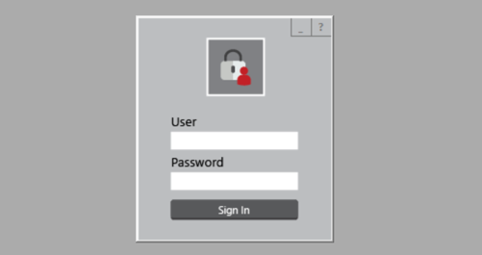

Orchard Work Centers
Your Orchard work center is a quick access area where you can find your most used Orchard applications.
How to set up your Orchard Work Centers:
At the top of your screen go to “File”, and then “My Work Centers”.
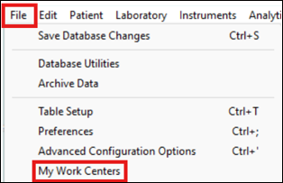
Now you are in “Work Centers Preferences”. On the left side you can select the applications that you want as part of your Work Center. To move the applications, use the arrows. Make sure that you include the following applications:
- Released Stored Orders
- Find a Patient
- Reference Labs
- Order Choice Catalog
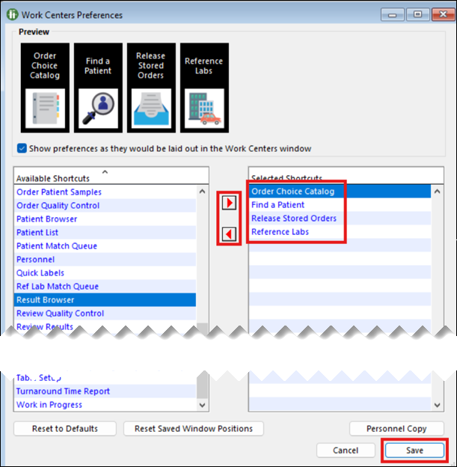

Your main Orchard screen should now look like this.
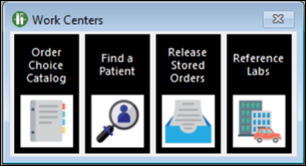

Release Stored Orders
This is the first screen you will see after you sign in.
To see orders that have come over from Epic, click on Release Stored Orders (RSO). This will often be referred to as RSO. All orders that have been signed in Epic will appear in the RSO list.
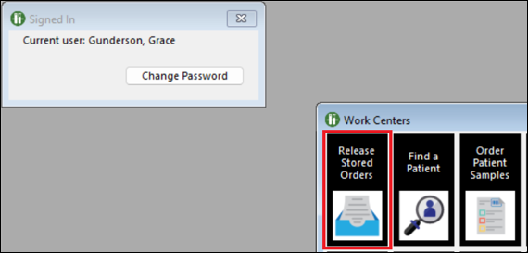
This screen shows all pending orders.

There are two main tabs that you will be working out of: Deferred Orders (D) and Host Orders (H). When an order is placed in Epic and sent, it lands in Orchard as a Host order. When you process and save an order in Orchard, it then becomes a Deferred order.
CL only looks at orders in the Deferred status. CL might refer to Host orders as “unreleased”.
The following sections will go over how to process an order in Orchard.
It is easiest to use this screen if you alphabetize the patient names by clicking on Patient Name (below Recurring Orders). Find the patient you want by typing the first few letters of their last name and verify with the Patient ID. The patient date of birth will be visible on the next screen.
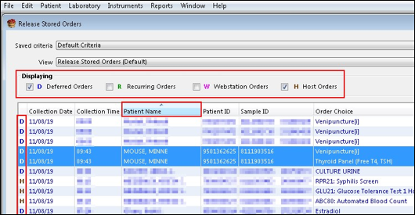
Once you have found the patient you are looking for, highlight the orders you want to release. Click on each order while holding “Ctrl”. This will allow you to select or deselect specific orders.
- Be sure that you are only releasing the orders being collected. If you release an order that is not going to be used that day, contact CL to cancel the order.
Click on Edit via Entry Screen in the bottom right corner to move forward.
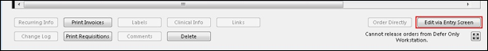

Find a Patient
You can find this feature in your Work Center. Click on “Find a Patient”.
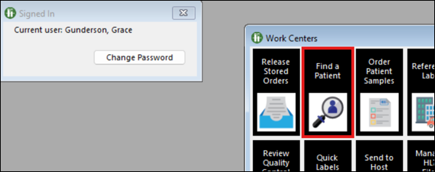
You can search for a patient on this screen or by a sample. If you want to search for a sample, you can put in the sample ID. When searching for a patient there are several different criteria you can search based on.
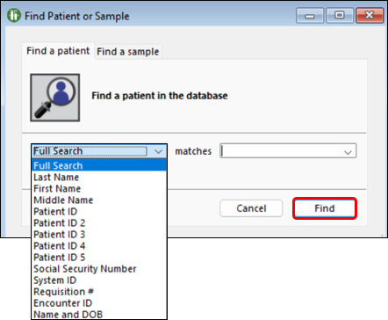
For this example, we will search by name. Once you have put in your patient’s information, you will be directed to their Orchard chart. Confirm you are looking at the correct patient by checking their name, MRN, and DOB.
Once you are in the patients chart you will see four tabs at the top: Patient Info, Encounter, Insurance, and Results Explorer. Click on Results Explorer.
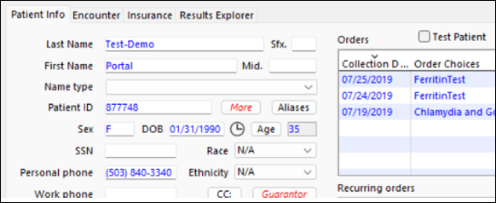

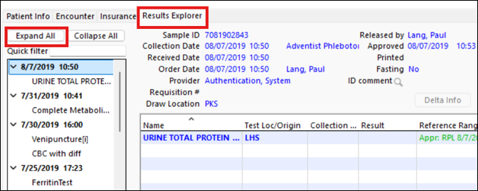

Once in Results Explorer, click Expand All and you can see all the tests this patient has had done (that have been processed in Orchard). This information is useful if you need to look at what labs a patient has had done or need to reprint labels.

Reference Labs
This section will be used the most for sending electronic orders to PSC. After you complete the PSC workflow it directs you to release the orders from the “Reference Labs”.

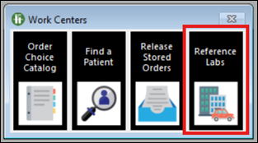

Now in Reference Labs a screen will pop up that has patient information as well as what tests are being sent. At the top left of the screen there will be tabs for each reference lab. Once you have selected the tests are you sending, highlight them and hold “Alt”, then “Create Batch”.
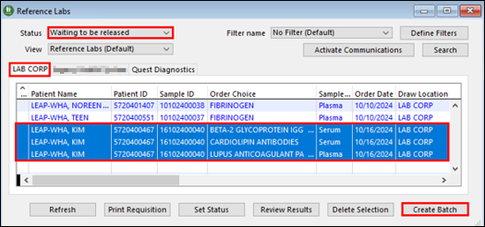
The orders have now been sent to the reference lab.
Tests are not electronically sent until they are batched and released from Reference Labs.

Order Choice Catalog
In Order Choice Catalog you can see details of every test in Orchard. Click on the application to get started.
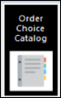

Select the test you want to learn more about. For this example, we are looking at ABC.
You will be able to see the full name of a test, abbreviation, sample type, storage temperature, tube/container, and if it is a panel test you will be able to see all the components.
You can also see the associated Quest and LabCorp test codes.
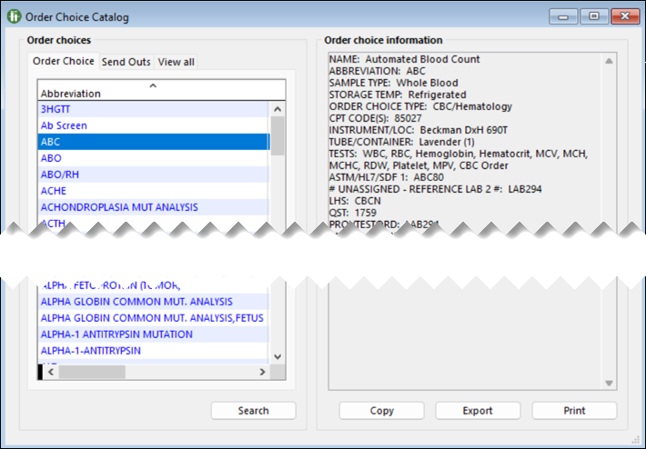
This source is important to be familiar with in case you need to get a test code for a wildcard order.

Processing OB Panels, Pap Smears, Urine and Biopsies
Familiarize yourself with the “Released Stored Orders” section before moving onto processing.

OB Panel
In this screen, Minnie Mouse has an OB panel
- To select the OB panel and the venipuncture associated with it (to confirm which venipuncture to use, confirm the last four digits of the sample ID before the box and make sure they all match), hold the Ctrl key while you click on the order.
- This allows you to process the specimen you have while leaving the rest of the order in RSO.
- Process only those specimens you have.
- Click Edit via Entry Screen button to continue processing the specimen.

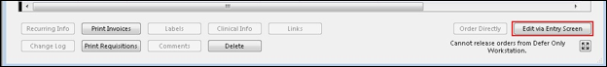

Now you are in the Order Patient Samples screen:
In this screen there are several areas you need to confirm and update.
Patient Information: Confirm in the top left corner of the screen that you are processing orders for the correct patient.
- Confirm name, DOB, and MRN (Patient ID)
Draw Location, Provider, Phlebotomist, Order Location: Top right corner of the screen. These areas should automatically populate but confirm that all the information is correct. You will need to change the phlebotomist to the person who collected the sample (select patient if the sample was self-collected).
Tests: In the middle of the screen, you will see what tests are being processed. The test location will automatically populate.
- Confirm the correct tests are being processed.
Collection Information: Near the middle of the screen there will be a space to update the collection date and time.
- Hit “Now” and it will populate the current date and time. Confirm that this matches the actual collection information of the sample.
Defer this Order: This should always be selected, confirm that it is.
Save Order: Located at the bottom right of the screen select “save order” if you have confirmed all the other information is correct.
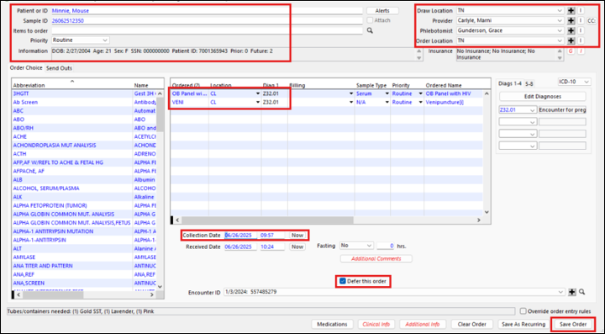

- The Confirm Labels screen will pop up.
- There are three tubes required for an OB panel and as you can see, there are three specimen container labels.
- Click OK to print labels.
It is IMPORTANT to verify the labels are correct by showing them to your patient, having the patient initial all labels, and to label the specimens in the presence of the patient.
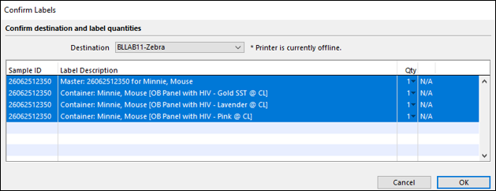
When you have completed all steps, Orchard will return you back to the blank Order Patient Samples screen.
- Click on the red X and you will be back in Release Stored Orders.

Urine

To select the Urine Culture, confirm the last four digits of the sample ID before the box and make sure they all match (also confirm Patient ID), hold the Ctrl key while you click on the order.
- This allows you to process the specimen you have while leaving the rest of the order in RSO.
- Process only the specimens you have in front of you.
- Click Edit via Entry Screen button to continue processing the specimen.

The Order Patient Samples screen then comes up.
- The Phlebotomist is changed to the name of whoever collected the specimen, if the collector is unknown select Patient as the Phlebotomist.
- Change the Collection Date and Time.
- Click Save Order.
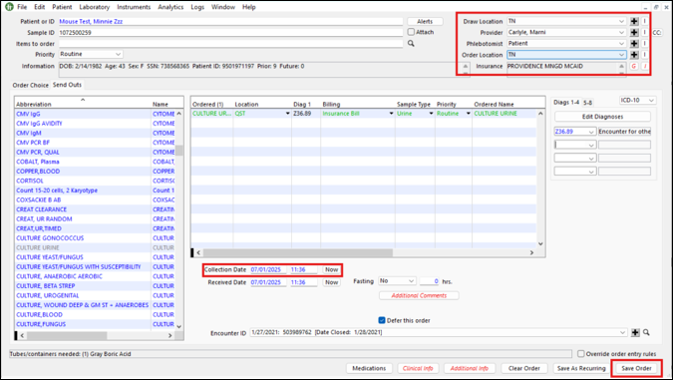
The next screen is the Clinical Information screen.
- An order entered, filled out, and signed in Epic will auto-populate with any specimens that require clinical information. Ensure all required fields are filled.
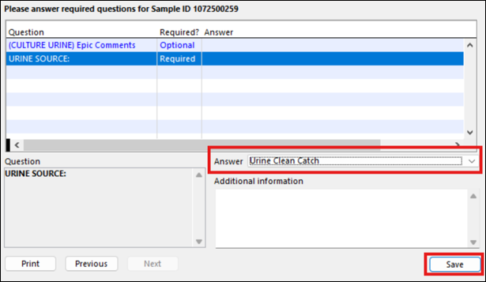

Click on the second question. This question is required for the source.
For this urine select Urine Clean Catch.
Click Save.
Now, you are in the Confirm Labels screen. You will need 1 master label and 1 specimen label. Place the master label on the specimen log kept in the lab.
Click OK.
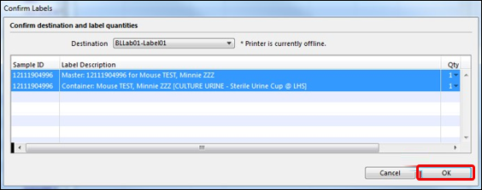

Verify the patient’s name and birth date on the specimen as well as on the Orchard labels. Then place the Orchard label on the specimen. Do not cover any previous labels. If you have to cover part of a previous label, try to leave as much of the patient’s name and MRN visible as possible.
Click the red X to get out of Order Patient Samples and bring you back to Release Stored Orders.

Pap Smear
There are three Pap Smear orders:
- Pap with HPV
- Pap, HPV if ASCUS
- Pap NO HPV
The Pap with HPV splits into Pap smear and HPV with Reflex to Genotyping. NOTE: The Pap smears are sent out and the HPV is performed in-house.

Confirm all patient information before moving onto collection information.
Confirm all collection information, phlebotomist will be the provider who collected the pap smear.
- Click Save Order.
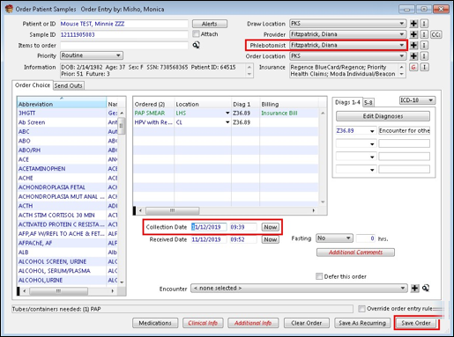

HPV is run at Central Lab.
Click “OK” and move onto the Clinical Information.
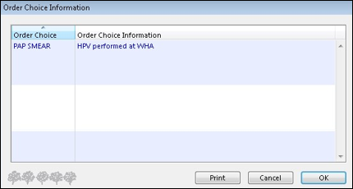
For Pap smears, cultures and biopsies, an order is placed in Epic with the clinical information entered.
The information entered into Epic electronically transfers into Orchard. Any Required information that was not entered must be satisfied by entering a dash (-) or 0 to complete the information below in the Question box.

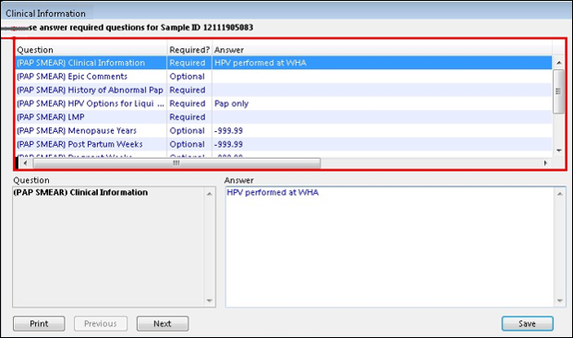

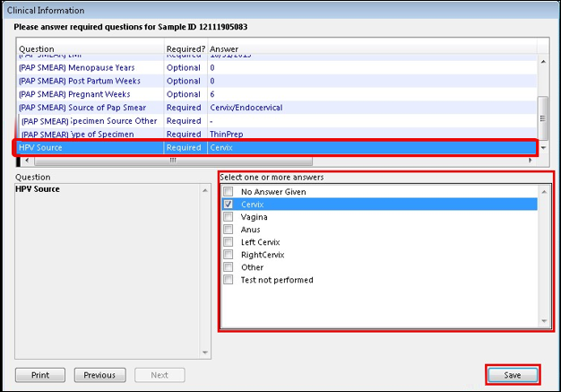

When processing a pap smear you need to fill out ALL clinical information. Please take the time and get familiar with each question being asked to ensure there are no errors being made while processing.
- Central Lab does not typically review this information; they trust that the clinical staff who are ordering the tests are filling out the clinical information properly.

Confirm Labels.
- A label does not print for the HPV.
- The Orchard label for a pap with HPV should be placed in the bag with the pap and not put on the pap container.
- The Central Lab staff will place the label on the container for these to accommodate the analyzers that perform the HPV testing.
- Verify that all information matches and that there is an Epic label on the pap specimen.
- Place the pap, Orchard requisition, and label in a green bag and leave at room temperature.
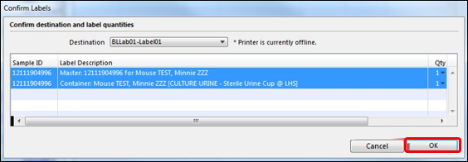

If the provider is ordering just HPV, process like normal and place a note in the specimen bag that the sample is for HPV only. The Thin Prep still needs to be labeled with the Epic label. Central Lab will take care of the rest.

Tissue Pathology
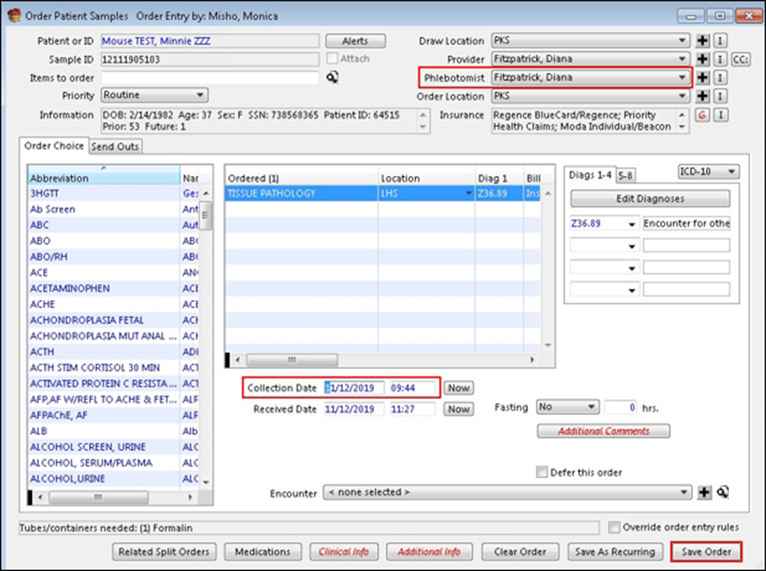

Biopsies often have more than one specimen.
There will only be one tissue order per patient, you do not need to put in multiple orders for the same patient. You do need to properly label every sample. Print as many labels as needed.
- Fill out all the required questions. Each specimen source needs to match exactly what is on the container. If there are any discrepancies the Central Lab may send the sample back to be labeled/documented correctly.
- For any required questions that you do not have a sample for put (-).
Once all specimen sources are listed, click Save.
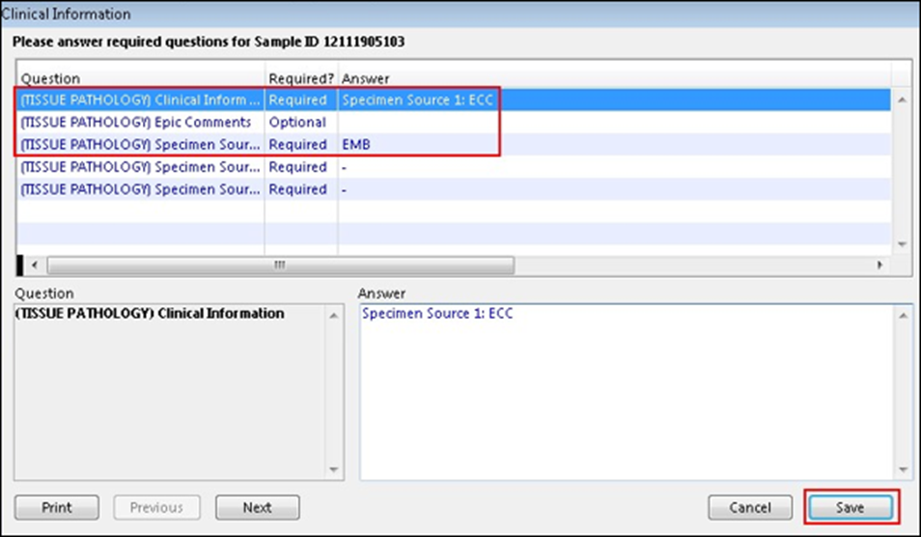

If you have more than one specimen, please add the sources to the clinical information section.

Draw Station Workflow
Please review the complete Draw Station Workflow here: Patient Service Center Guide (LabCorp and Quest)
WHY? This workflow is for patients who need to have labs drawn that WHA cannot collect. Patients can choose between Quest or LabCorp to have electronic orders sent. For patients that are requesting to have labs drawn at a lab that is not LabCorp or Quest, the order will need to be faxed, and it is up to the clinic to track the results.
The following shows how to process these orders in Orchard:
Open RSO in Orchard. Find your patient and highlight the orders that need to be done at a draw station. Click Edit via Entry in the bottom right corner of RSO.
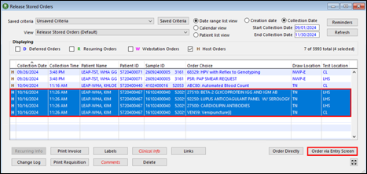
Change the following fields:
- Draw Location: Quest/LabCorp
- Phlebotomist: Quest Phlebotomy/ LabCorp Phlebotomy
- Location: QST/LABCP
- Collection Date: 00/00/0000 Time: 12:00PM
- Received Date: 00/00/0000 Time 12:00PM
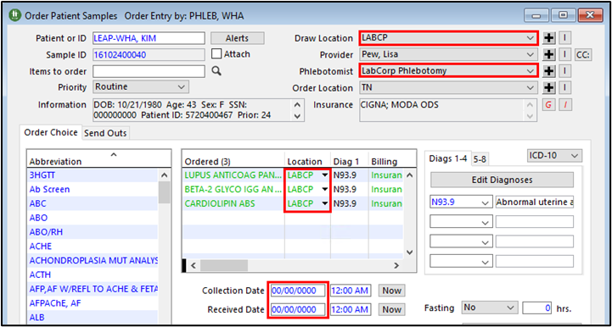

It is important that the test location and draw location match. If they do not match (draw location: LabCorp and test location: Quest) then the order will not be sent.
Uncheck the Defer this order box in the bottom right corner of the window and click Save Order.
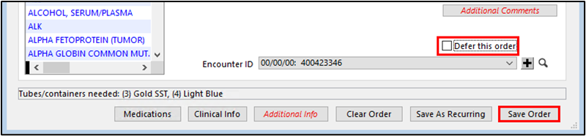

In the toolbar at the top of Orchard, click Laboratory to open the drop-down menu. Select the Reference Labs activity. This can also be added to your Quest workstation.
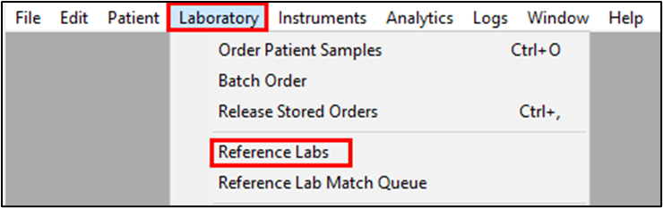

In the Reference Labs activity go to the Quest or LAB CORP tab. Ensure the Status is set as Waiting to be released.
Select the applicable orders. Hold Ctrl while clicking the labs to select more than one at a time. Click Create Batch, hold Alt to bypass the Print dialog box.
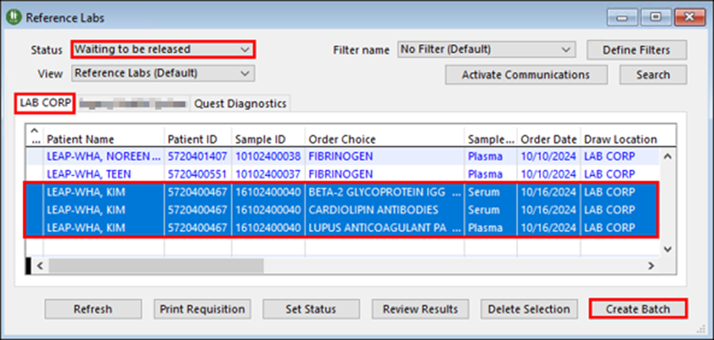

The order has now been sent electronically to the reference lab.
Problem solving draw station workflow issues:
Q: The patient is at the draw station, and they said they never received the orders.
A: If the draw station has not received the orders, there has likely been a processing error on our side. Recheck the orders by using “Find a Patient”. You can learn more about this function in the Orchard section. In “Find a Patient”, the order may still be in “unreleased” orders at the bottom. If it is there you may not have unclicked the “deferred” box while originally processing the order.
A: The draw location and test location do not match. If these do not match, then the order will not be sent. You can confirm this by looking in the patients Orchard chart. You can learn more about this function in the Orchard section
A: The order is still in Deferred status.
Q: The patient wants to go to a lab/clinic that is not WHA, LabCorp, or Quest. How can I send those orders?
A: Patients should only be getting labs done at one of those three places. If a patient is insisting on having labs done somewhere else, then the clinical team can fax those orders. It is important to note that the Central Lab is only responsible for tracking results that are from LabCorp or Quest. It is the clinical team’s responsibility to track down all other lab results.
A: Please review this resource on how to send labs outside of LabCorp and Quest : Draw Stations Outside of Quest.LabCorp

WildCard Workflow
When a provider or clinical staff orders an "Unlisted Lab" in Epic, it comes across in Orchard as "Wild Card Test One". In the RSO, when the LA/MA begins processing the order, a specific set of required questions must be answered. This information does not carry over from the Epic order, so it will need to be re-entered manually in Orchard.

The questions are as follows:
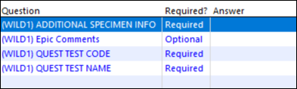
Quest Test Code: This test code can be found using the Order Choice Catalog. Please review that section for more information.

Quest= QST

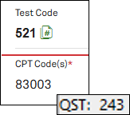

A common error done while filling out this information is putting the diagnosis code where the test code goes. Putting the correct test code helps both the Central Lab and Quest staff understand what test is needed.

Quest Test Name: Enter the full name of the test being ordered.

The default testing location of a WildCard is Quest. If you have a patient who is going to a LabCorp draw station and the order needs to be a WildCard, use the following information to ensure all required sections are correct:
- Change the testing location to LabCorp
- Find the LabCorp test code via the Order Choice Catalog. LabCorp= LABCP
- Finish routing orders electronically (Patient Service Center Guide (Labcorp and Quest))

Quest Test Menu
Follow this link to get to the Quest Test Menu: Quest Diagnostics: Test Directory

Quest has several order choices that we do not use. WHA has preferred orders that match up with what our providers are looking for. To ensure you are looking at the correct order, find the QST code in the Order Choice Information section in Orchard. This QST code will bring you to the correct test.

This is the first screen you will see when you click the link. This is where you can search for tests by name, test code, or CPT code.
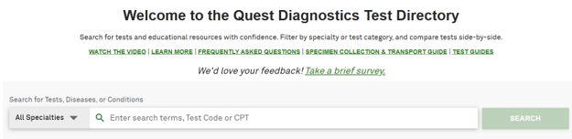

Type in the code for the test you are looking for. The results that pop up will be in order of strength (strong to weak match). For this example, we will use a common send out test: Testosterone, Free and Total (includes: SHBG) test code: 37073. Select the test.

After selecting the test, you will go to the test information page. We will look at the top of the page first:
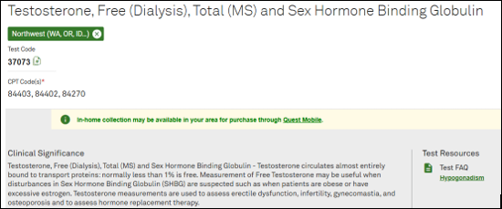

At the top of this page, you will find the full test name, test code, and clinical information. This information will be useful when you need to place a Wild Card (Unlisted, Wild1) order.

The CPT code(s) are only used by Quest for billing purposes.

The bottom of the page contains all test details. This information will be useful when you need to know stability or components of a test.
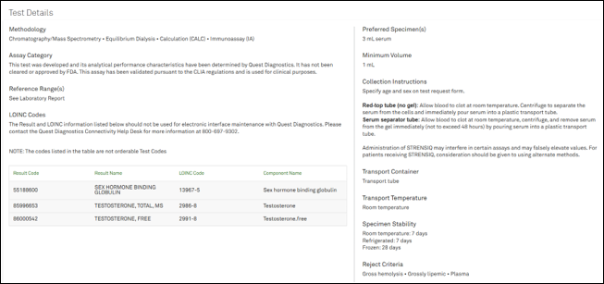

If you have any questions or need clarification, contact the Central Lab

Quick Links

Resource | Link
24-Hour Urine Collection Guide | 24 Hour Urine Collection Patient Instructions
24-Hour Urine Collection Guide Spanish | 24 Hour Urine Collection Patient Instructions-Spanish
Blood Collection Guide | C-17 Blood Specimen Collection & Competency Checklist
Common Acronyms | Common Acronyms
Culture Test Order Guide | WHA Culture Tests
Documenting Adverse Reactions | Documenting an Adverse Reaction
Draw Station Workflow | Patient Service Center Guide (Labcorp and Quest)
Draw Station Workflow- Outside of LabCorp and Quest | Draw Stations Outside of Quest.LabCorp.docx
GTT Guide | Glucose Tolerance Test Guide
LabCorp Draw Station Locations | Find a Labcorp Near You
New Hire Workflow | New Hire Lab Draw Workflow- March 2025
Quest Draw Station Locations | Oregon and Southwest Washington Quest Draw Station Locations
Quest Draw Station Order Choices | Quest Draw Station Order Choices
Quest Test Menu | Quest Diagnostics: Test Directory
Swabs and Orders Tip Sheet | Swabs & Orders
Urine Collection Guide | Quest Urine Collection Containers and Orders
Urine Transfer Guide | Transferring Urine Preservative Tubes for Transport
WHA In-House Stability | WHA In-House Stability CLINIC VERSION

Helpful Hints

- Orchard is the name of the software we use in the lab.
- Under CLIA law it is illegal for Lab Assistants (this includes Medical Assistances acting as Lab Assistants, (ex: Medical Assistants in Extended Hours) to be entering and signing orders for patients. If you cannot find an order in ROS or Epic, communicate with the support staff of the patient’s provider, or the provider themselves to ensure the orders were entered and entered correctly.
- The bar code relays the patient information as well as the tests ordered to the analyzers, therefore it is important that the label is placed on the tube straight and smooth.
- If there are in-house tests and send-out tests ordered, there will be at least two screens to work through in Orchard. This is because the system requires different sample ID numbers so the order splits. The send-out tests are in all CAPITAL letters in the RSO (release stored orders) and has a different sample ID number.
- Draw a tube for each label that prints from Orchard. The label will indicate which tube is required and is printed in the order of draw.
- Place the Orchard label on the corresponding tube; for example, place the label that says SST/gold top tube on the SST/gold top tube, the label that says EDTA/lavender on the EDTA/lavender tube. We use the correct label to indicate which tests are being performed in each tube. By labeling samples correctly, it will make running the sample and getting results smoother.
- It is important to give the lab all pertinent clinical information. When you are processing a sample that requires clinical information, there will be “required” and “optional” fields, you need to fill out every “required” field. Examples of this are sources for cultures and biopsies, fasting status, time of last dose, penicillin allergy, LMP for paps.
- Show Orchard labels to the patient for confirmation, have them initial each label after it’s been checked for accuracy, and label specimens in the presence of the patient.
- The Orchard requisition for send out tests is the only paperwork sent with the specimen; therefore, it is very important that all clinical information is accurate.
- All labelling and processing errors will be recorded on a Compromised Specimen Form, which will be documented in RLDatix for your PCS to review.

FAQ
Q: Why can’t I find this patient’s orders in Orchard?
A: Have you checked in the patient’s EPIC chart under the show orders button to verify orders have been placed or if they need to be released?
A: Are the “start and end” collection dates at the top right side of your screen set correctly?
A: Do you have the Deferred and Host order boxes checked?
A: Have you clicked “refresh”?
Q: Why is the order info “greyed” out and it won’t let me change the date, time, or phlebotomist?
A: There was a specimen with the same sample ID that was previously released. You will need to have a new order placed or Central Lab can “split” the test (splitting the test refers to two new sample IDs being made so the tests in question do not share).

Q: What should I do if I am processing a specimen and notice there is another specimen with the same sample ID that is not being processed?
A: Call the Central Lab @ x1215 and have someone delete the test not being processed.

Q: What should I do if the WHA courier has already picked up for the last time today and won’t be back until tomorrow?
A: Confirm the stability of the sample and if it can wait until the next pickup. If you have questions about the stability of the sample call Central Lab.
At the end of the week, IT suggests restarting your desktop at least once per week, this is generally best done on a Friday evening just before you leave. To close out of Orchard, click File then Exit. Then you’ll be able to restart easily.
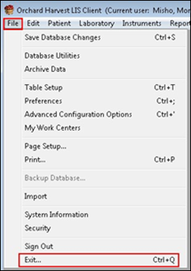

Be sure to sign out of Orchard when you are not using it by clicking on the red X in the sign-in box as seen below.
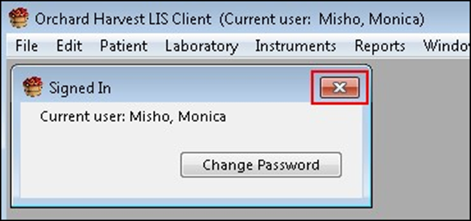

Genetic Tests to Quest
Please contact Amanda Carter for ALL genetics questions.

Sequential Screening will go to Quest.
- When sending genetic tests to Quest, the draw location automatically populates to show NWP for genetic testing.
- The Provider is the ordering provider.
- There is a pop-up to prompt you to spin the tiger top tube in the centrifuge after letting it sit for 30 minutes and to then store it at room temperature. Click OK.
- A pop up will then prompt you to change the Draw Location. Click OK.
- Everything else is processed like any other specimen.
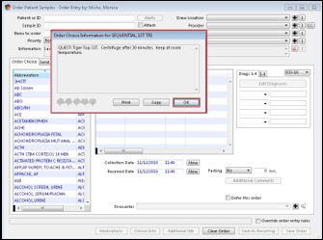
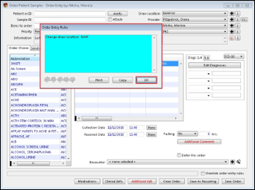

Everything else is processed like any other specimen.
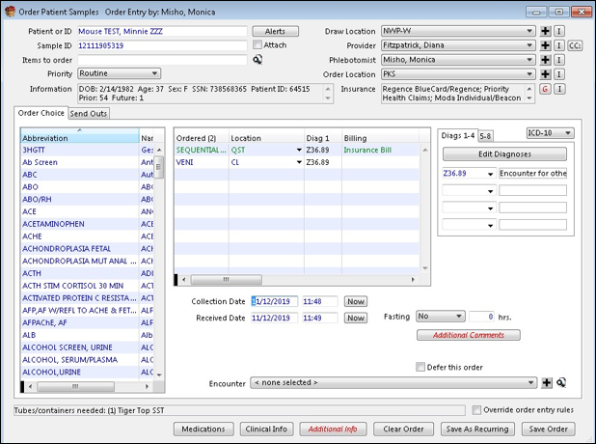

Consent Forms - Genetic Pathology & Blood Collection

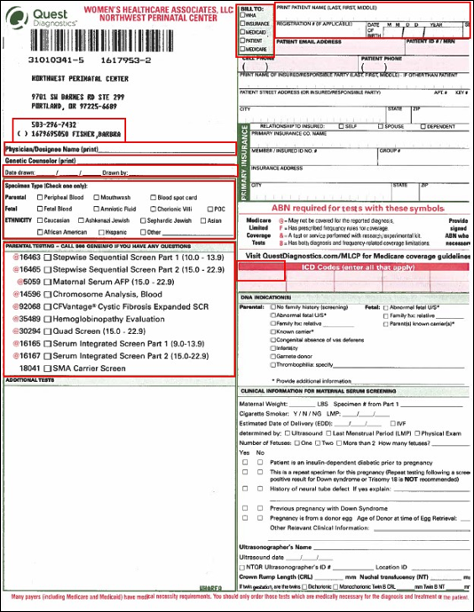
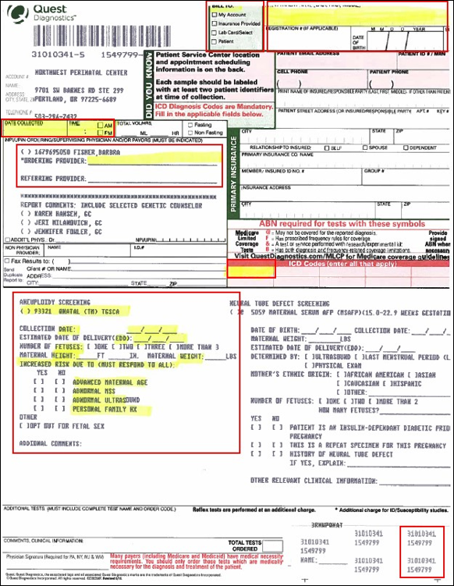

SST – Red/Yellow Top

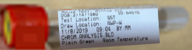

Required Label(s): Orchard, Quest requisition sticker

Labeling Instructions: Print label from Orchard, have patient initial in blank space after verifying identity, place on tube while leaving open space to see blood level in tube.

Packaging Instructions: Allow to clot for 30 minutes at room temperature, spin in centrifuge within 2 hours, place in a specimen bag. **Note: For genetic testing, keep at room temperature for courier pickup.**
Place in foam holder for transport.

Common Errors: Patient initials not on label

Common Tests: Genetic testing (Sequential Screening)

